Test 15

- NOM :…………………… PRENOM :………………………….. 2nde

NOTE : | OBSERVATIONS :

EXERCICE 1 (2 points)
1) Comment s’appelle la relation qui permet d’écrire + =
………………………………………………………………………………………………………

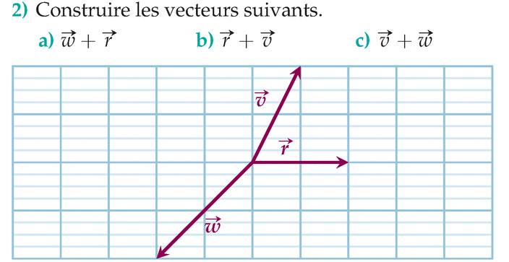
EXERCICE 2 (3 points)

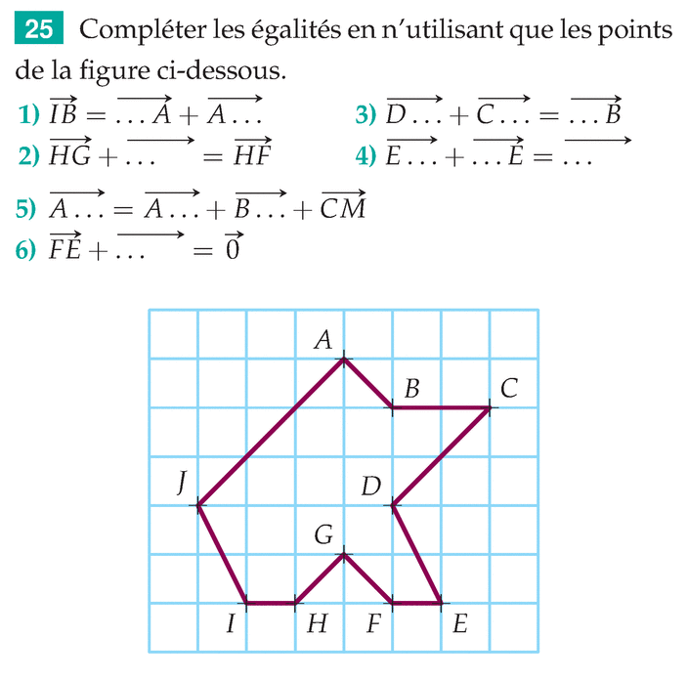

EXERCICE 3 (3 points)

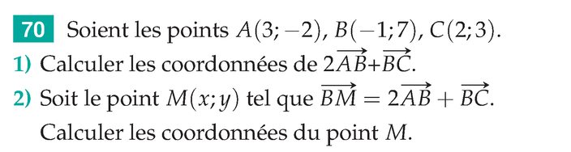
………………………………………………………………………………………………………………….
………………………………………………………………………………………………………………….
………………………………………………………………………………………………………………….
………………………………………………………………………………………………………………….
EXERCICE 4 (2 points)
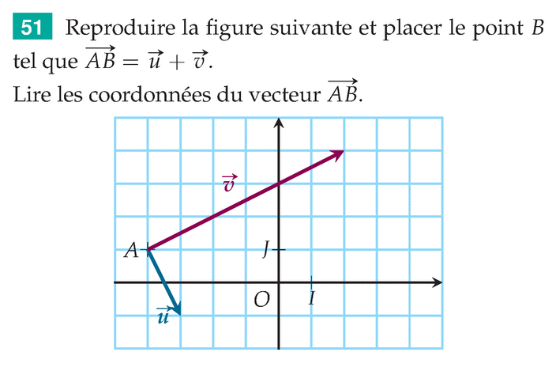

…………………………………………………………
…………………………………………………………

BON COURAGE !

