Test 16

- NOM :…………………… PRENOM :………………………….. 2nde

NOTE : | OBSERVATIONS :

EXERCICE 1 (2 points)
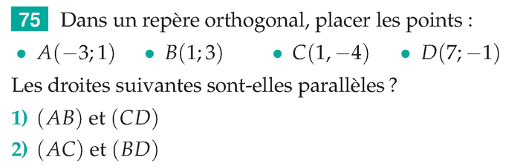
………………………………………………………………………………………………………………….
………………………………………………………………………………………………………………….
………………………………………………………………………………………………………………….
………………………………………………………………………………………………………………….
………………………………………………………………………………………………………………….
………………………………………………………………………………………………………………….
………………………………………………………………………………………………………………….
………………………………………………………………………………………………………………….
EXERCICE 2 (3 points)

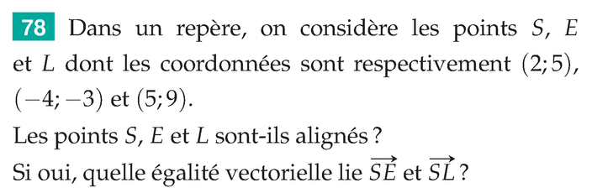
………………………………………………………………………………………………………………….
………………………………………………………………………………………………………………….
………………………………………………………………………………………………………………….
………………………………………………………………………………………………………………….
EXERCICE 3 (4 points) EXERCICE 4 (1 point)

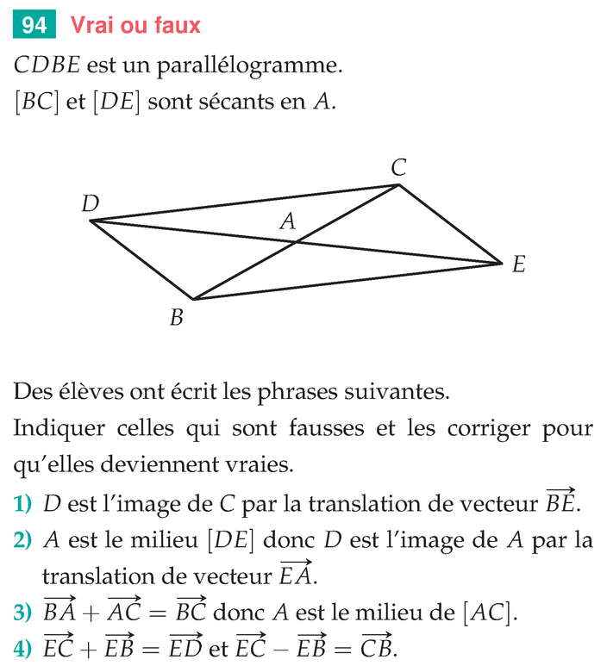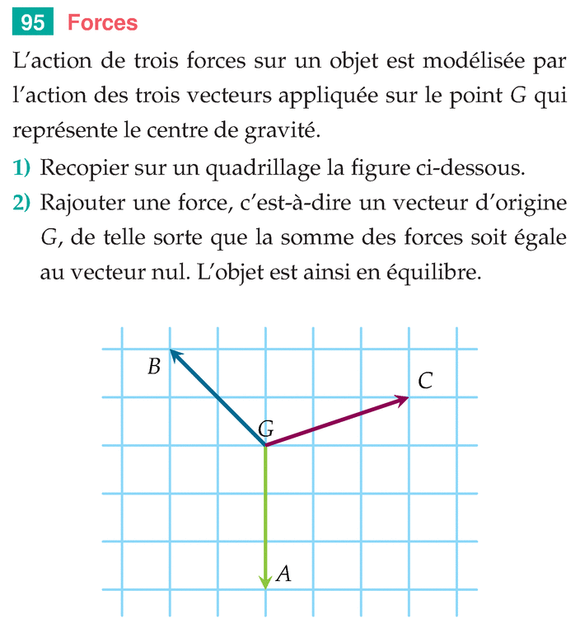
1) Chercher le point D, tel que GD + GA + GB + Gc = 0
2)
3)
4)
BON COURAGE !

