Test 3
- NOM :…………………… PRENOM :………………………….. 1ère S

NOTE : | OBSERVATIONS :

EXERCICE 1 (2 pts) Résoudre
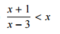
...................................................................................................................................................................................
...................................................................................................................................................................................
...................................................................................................................................................................................
...................................................................................................................................................................................
...................................................................................................................................................................................
...................................................................................................................................................................................
...................................................................................................................................................................................
...................................................................................................................................................................................
...................................................................................................................................................................................
EXERCICE 2 (2 pts) Résoudre
...................................................................................................................................................................................
...................................................................................................................................................................................
...................................................................................................................................................................................
...................................................................................................................................................................................
...................................................................................................................................................................................
...................................................................................................................................................................................
...................................................................................................................................................................................
...................................................................................................................................................................................
...................................................................................................................................................................................
...................................................................................................................................................................................
...................................................................................................................................................................................
...................................................................................................................................................................................
...................................................................................................................................................................................

EXERCICE 3 (2 ptS)
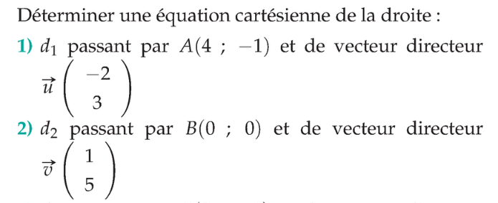
( On utilisera deux méthodes différentes pour ces deux questions )
...................................................................................................................................................................................
...................................................................................................................................................................................
...................................................................................................................................................................................
...................................................................................................................................................................................
...................................................................................................................................................................................
...................................................................................................................................................................................
...................................................................................................................................................................................
...................................................................................................................................................................................
...................................................................................................................................................................................
...................................................................................................................................................................................
...................................................................................................................................................................................
...................................................................................................................................................................................
...................................................................................................................................................................................
...................................................................................................................................................................................
...................................................................................................................................................................................
...................................................................................................................................................................................
...................................................................................................................................................................................
...................................................................................................................................................................................
EXERCICE 4 (2 ptS)
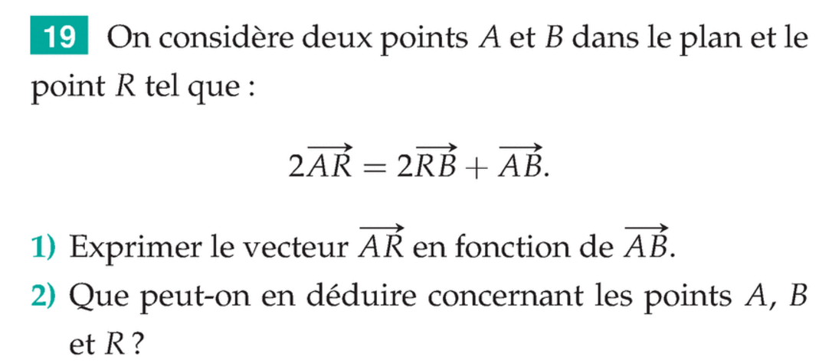
...................................................................................................................................................................................
...................................................................................................................................................................................
...................................................................................................................................................................................
...................................................................................................................................................................................
...................................................................................................................................................................................
...................................................................................................................................................................................
...................................................................................................................................................................................
...................................................................................................................................................................................
...................................................................................................................................................................................
...................................................................................................................................................................................
...................................................................................................................................................................................
...................................................................................................................................................................................
...................................................................................................................................................................................
...................................................................................................................................................................................
...................................................................................................................................................................................
...................................................................................................................................................................................
...................................................................................................................................................................................
...................................................................................................................................................................................

EXERCICE 5 (2 ptS)
...................................................................................................................................................................................
...................................................................................................................................................................................
...................................................................................................................................................................................
...................................................................................................................................................................................
...................................................................................................................................................................................
...................................................................................................................................................................................
...................................................................................................................................................................................
...................................................................................................................................................................................
...................................................................................................................................................................................
...................................................................................................................................................................................
...................................................................................................................................................................................
...................................................................................................................................................................................
...................................................................................................................................................................................
...................................................................................................................................................................................

Bon courage !

